Iftiar Rana

Exploring Cowboy Bebop

**Forewarning: There may be spoilers in this paper. If you don’t want to be spoiled about the anime, it is best you stop from further reading.**

**Introduction & Background**

This paper is about the anime *Cowboy Bebop*. I watched it during January 2021. Cowboy Bebop is about bounty hunters searching for criminals. Criminals that are wanted are listed in what is called a bounty. In their world, bounty hunters are known as cowboys and the Bebop is the name of the space ship the main characters use and the organization name of the crew themselves.

**Warning: There may be spoilers. Do not proceed any further if you are interested in watching the show.**

I will be discussing about the following:

* The crimes bounties have committed to land themselves on the hunt
* The location of the bounties
* Bounty Rewards
* How much the Bebop made and miss in their hunts
* The Success and Failure of the Bebop in their hunts

**Method**

As mentioned earlier, I watched the show. I watched one episode at a time and collected as much information as I can find about a bounty. Most episodes, including the movie which is canon, has at least 1 bounty featured and a couple of episodes have multiple. I then categorized each variable and placed them on an Excel worksheet. I used RStudio to clean up the data and create the graphs. All the codes, graphs, this report and worksheet will be seen in my GitHub portfolio. You can access it by clicking here: <https://github.com/IR-IR>

**General Information About the Bounties and the Bebop World**

* There are 24 bounties total
* The universal currency used is known as Woolongs (￦). It was never made clear how much exactly a Woolong is worth. However, it appears that the Woolong worth is roughly on – par with how much the Japanese Yen is worth during the mid – 1990s, when the show was released. Maybe with a slight inflation. Think 1 ￦ = .01 USD
* Some of the bounties landed on the list for multiple crimes. Furthermore, the crimes themselves are listed as exactly as the show and the Cowboy Bebop wiki does. That’s why you will see crimes such as “Robbery” & “Bank Robbery”, “Murder” & “Unintentional Murder”.
* For the crimes committed, that information came from the “Criminal Records” section whenever a bounty is shown on their TV or when they are in the act of committing a crime. I also paid close attention to detail in each episode/session. For example, Faye said “Mao Yenrai is wanted for murdering a crime boss” (Session 5).
* “Unknown” will be present in some of the data. That is because the show never made it clear such as where a bounty was located, the crime they committed that landed them on the bounty, how much a bounty is worth, etc.
* The Bebop is a crew full of experienced bounty hunters. The data only show the ones the show mentioned on – screen.
* As for whether a reward has been collected, you will notice it has 2 choices. Sometimes the show didn’t make it clear about whether the reward has been collected. I made a guess based on the episode’s context. However, that is only for 1 bounty, Dr. Londes. All the others were made clear.
* Bounty hunters here are also known as cowboys

**Table of Content**

Section ......................................................................................................................... Page

Crimes That Landed Criminals on the Bounty ………………………………………. 5

The Location of the Bounties …………………………………………………………. 7

Bounty Rewards ………………………………………………………………………. 8

The Success and Failure of the Bebop in Capturing the Bounties ……………………. 12

The Fate of the Bounties ………………………………………………………………. 13

**Crimes That Landed Criminals on the Bounty**

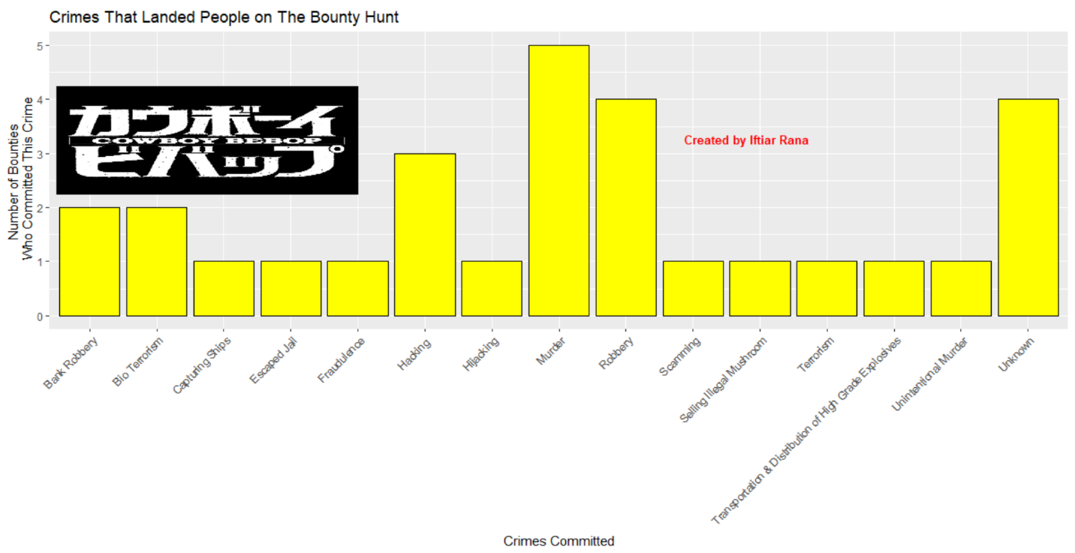

The graph may be difficult to read. Below the basic layout.

Title: Crimes That Landed People on The Bounty Hunt

X – axis: Crimes Committed

Y – Axis: Number of Bounties Who Committed the Crime

|  |  |
| --- | --- |
| Crimes Committed | Number of Bounties Who Committed the Crime |
| Bank Robbery | 2 |
| Bio Terrorism | 2 |
| Capturing Ships | 1 |
| Escaped Jail | 1 |
| Hacking | 3 |
| Hijacking | 1 |
| Murder | 5 |
| Robbery | 4 |
| Scamming | 1 |
| Selling Illegal Mushroom | 1 |
| Terrorism | 1 |
| Transportation & Distribution of High-Grade Explosives | 1 |
| Unintentional Murder | 1 |
| Unknown | 4 |

Essentially, we see most criminals who got a bounty on their head landed themselves there by committing crimes that have been crimes for a long time. Most common crimes are murder (6 total) and robbery (6 total).

There are 4 bounties whose crimes we don’t know. One was mentioned in the first episode but we have no identity. Jet just casually mentions that they successfully captured a bounty. Another was Morgan. Jet and Spike were just casually spying him and identifying who he was (Session 4). They never went into what crime he committed to be on the bounty. There were 2 criminals mentioned on Session 10 by Edward when Faye inquired how Ed knew so much about Bebop. One was Ajiz and the other was never named.

In our world, the equivalent would be getting financial reward for information or capture (via citizen’s arrest) of a person on a WANTED list. It’s probably safe to assume that crime and prosecuting criminals in their world is very similar to our reality.

Note: If you want to, you can count Transportation & Distribution of High-Grade Explosives and Selling Illegal Mushroom under one common crime – distributing illegal substances

**The Location of the Bounties**

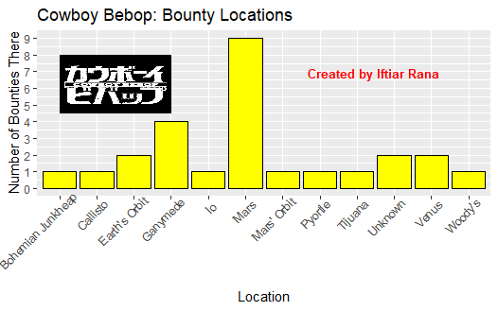

The graph above shows the location of all the bounties when they were first spotted. It doesn’t necessarily mean that’s their home or they stay in one place. Majority of bounties were found in Mars. Keep in mind, in the Bebop’s world, Mars is the most populated planet. Therefore, it makes sense for most of the wanted bounties to be there. The more populated a place is, the more of a certain group there will be. This isn’t an absolute but has a tendency to be true.

The location of criminals is very diverse and spaced out in terms of physical space. It further shows how scientifically advanced their world is if they space travel is relatively common and affordable and Venus and Io, one of Jupiter’s moon, are habitable. The show takes place late in the 21st century so it makes sense for their world to be technologically advanced.

Note: It is possible for Woody’s (where Decker was located in Session 7) to be in Mars; however, that was not made clear.

**Bounty Rewards**

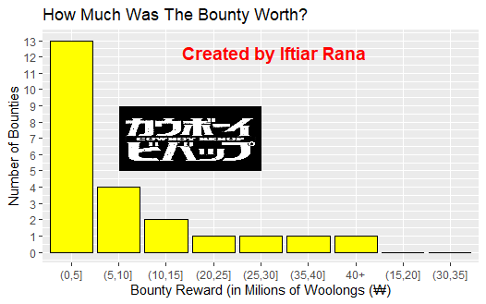

The graph above shows a bounty worth within a specified range. I chose this as the reward variable is continuous. I also chose the range of 5 million Woolongs so the data can fit within the graph. As I mentioned earlier, 1 Woolong is approximately equivalent to .01 USD. 5 million Woolongs ~ 50,000 USD, 10 million Woolings ~ 100,000 USD, 100 million Woolongs ~ 1,000,000 USD, etc.

From the chart, it appears majority of criminals are between 0 and 5 million Woolongs. However, the price range can be seen as too big. It’s important to further breakdown the ranges. I will also add the crimes committed for there may be a story to tell.

Table A: Further Breakdown of Bounties Worth Between 0 and 5 Million Woolongs

|  |  |  |
| --- | --- | --- |
| Range (in millions of Woolongs) | Number of Bounties in that Range | Crimes Committed |
| Less than 1: (0,1) | 3 | Bank Robbery (2)  Fraudulence  Murder (Unintentional) |
| 1 – 2: [1,2) | 6 | Unknown (2)  Hijacking  Murder  Selling Illegal Mushroom  Robbery |
| 2 – 3: [2, 3) | 1 (2.5 million Woolongs) | Murder |
| 3 – 4: [3, 4) | 2 (both worth 3 million Woolongs) | Murder  Terrorism |
| 4 – 5: [4,5] | 1 (5 million Woolongs) | Hacking |

Table B: Further Breakdown of Bounties Worth Between 5 and 10 Million Woolongs

|  |  |  |
| --- | --- | --- |
| Range (in millions of Woolongs) | Number of Bounties in that Range | Crimes Committed |
| 5 – 6: (5,6] | 1 | Scamming, Robbery |
| 6 – 7: (6, 7] | 0 |  |
| 7 – 8: (7, 8] | 3 | Robbery  Unknown  Hacking |
| 8 – 9: (8, 9] | 0 |  |
| 9 – 10: (9, 10] | 0 |  |

Table C: Further Breakdown of Bounties Worth Between 10 and 15 Million Woolongs

|  |  |  |
| --- | --- | --- |
| Range (in millions of Woolongs) | Number of Bounties in that Range | Crimes Committed |
| 10 – 11: (10, 11] | 0 |  |
| 11 – 12: (11, 12] | 2 (both worth exactly 12 million Woolongs) | Transportation & Distribution of High – Grade Explosives  Hacking |
| 12 – 13: (12, 13] | 0 |  |
| 13 – 14: (13, 14] | 0 |  |
| 14 – 15: (14, 15] | 0 |  |

Table D: Further Breakdown of Bounties Worth More Than 15 Million Woolongs

|  |  |
| --- | --- |
| Bounty Worth (in millions of Woolongs) | Crimes Committed |
| 25 | Bio Terrorism |
| 28 | Murder |
| 38 | Murder |
| 300 | Bio Terrorism |

Looking at all 4 tables, a story can be painted. The more severe a crime is, the more the bounty is worth. For example, in Table A, one crime committed was fraudulence. However, the perpetrator would con women into taking his debt. That bounty was worth 59,400 Woolongs. Whereas the 2 bank robberies were both worth 500,000 and 800,000 Woolongs. For the most part, bank robberies are seen as a more severe crime than fraud.

Murder is the most prevalent crime. Nearly every table has one. However, the bounty on it varies. Again, this attributes to the severity of a crime. Not all murders are equal. For example, murdering a private citizen vs a politician or police officer. The same must be held true in the Bebop world. For example, the 28 million Woolong bounty was on Mao Yenrai’s head. That was for murdering 1 person, a crime syndicate boss (the audience knows this is not true but not the Bebop crew or any other bounty hunter). The 38 million Woolong bounty was on Dr. Londes’ head. He created a movement called SCRATCH, the migrate to electronics movement, where people move to electronics and people leave their physical bodies to awaken their soul and join “the infinite sea of elections”. Consequently, multiple people commit suicide. Let’s look at a lower bounty – Rhint Celonias. He has a 1.8 million Woolong bounty on his head for murdering a loan shark. One single death of a loan shark is less than the death of a known figure (the crime boss) or the deaths of multiple private citizens. Hence, the lower bounty worth.

Therefore, we can come to the following conclusions:

* Bounty worth varies by crime and degree of crimes and impact and potential dangers on others (i.e., casualties, how much value they were robbed)
* No 2 crimes are the same.
* Most of the bounty the Bebop chased on screen have committed relatively “lower” crimes (i.e., robbing a bank, killing 1 private citizen, bombing places with no causalties). **This does not mean the crimes themselves are not serious. They are and should be taken as such.** Therefore, the bounties are on the lower end of the spectrum.
* Bounty worth has no upper limit.

Note: The reward for 3 bounties were not listed. Those were George, Herman, Ruth (space pirates), Gren, and the criminal who got caught by the cops in Pyortle.

**The Success and Failure of the Bebop in Capturing the Bounties**

For this purpose, I define success as whether the Bebop collected the reward on their bounties. I chose this definition because the job of the bounty hunter is to capture criminals and hand them over to the police. They then collect the reward. If cowboys don’t collect the reward, the hunt is a failure as this is their job.

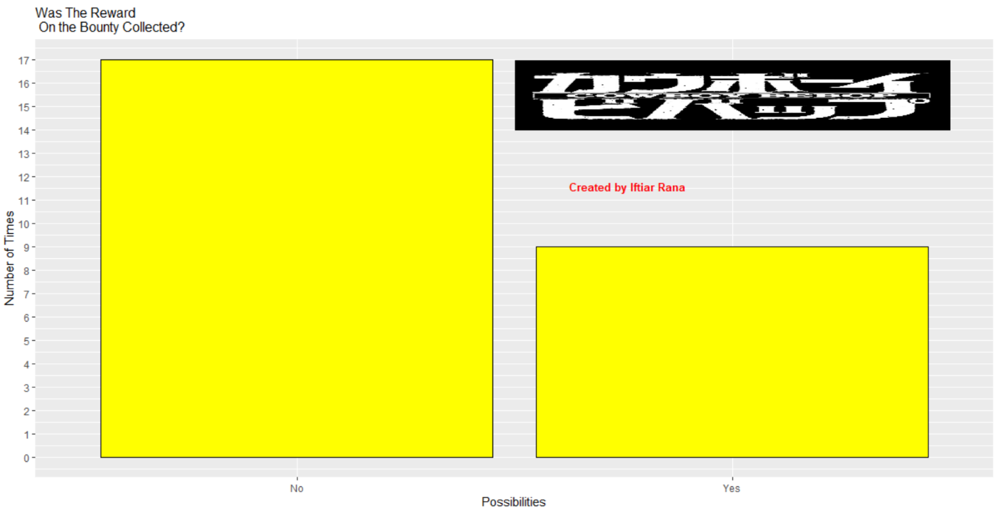

The graph above depicts whether the Bebop collected the reward on each of their hunts in the anime. They only collected rewards from 9 out of 26 hunts and failed to collect 17. That’s a success rate of 34.61%. Take ten hunts. The crew only gets paid for 3 or 4 of them. Speaking of getting paid, from those 9 times, the Bebop collected a total of 47,909,400 Woolongs; however, keep in mind this is from inferring the 38 million reward was collected as that is ambiguous. In the event it was not, then they collected a total of 9,909,400 Woolongs. The Bebop missed out on at least 387.2 million Woolongs (again some of the bounty rewards were not listed to the audience).

That would indicate a massive failure. However, the Bebop is well known in their universe. They are feared. Therefore, their failures cannot be attributed to incompetency. If it’s not due to incompetency, then why did they struggle?

**The Fate of The Bounties**

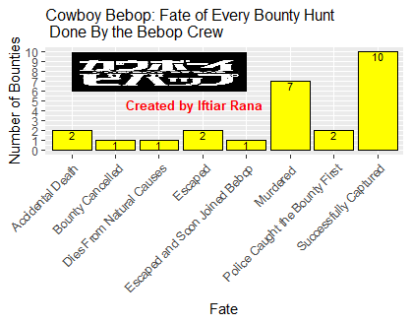

The graph above showed the fate of all the bounties shown or mentioned in the anime. Most of the bounties (9) died, whether by murder or accidental deaths. However, amongst the murdered, the Bebop had some control of their fate. Spike was able to successfully locate and chase Asimov (Session 1). Spike and Jet successfully located Morgan and could have apprehended him earlier (Session 4). Mao Yenrai was murdered prior to the bounty being listed (Session 5). Spike and Jet successfully located Giraffe (Session 6). Spike followed Giraffe and tried to rescue him after hearing shots fired but failed unsuccessfully (Session 6). However, Jet ran into an acquaintance who was hunting for the same criminal and had to stall him so Spike can sneak out and capture Giraffe (Session 6). Therefore, there was not much Spike nor Jet could have done. As for Gren in Session 12, Spike was able to locate him but he chose to go after Viscous as Spike perceived him to be more of a threat. Also didn’t help Viscous interfered with Gren’s capture. Lee Sampson was killed by Vincent Volaju even though Faye did locate him but couldn’t act upon capturing as Vincent also immobilized and poisoned her for a bit (Cowboy Bebop: The Movie). Vincent Volaju was killed by Spike and Elektra as there was no other option (Cowboy Bebop: The Movie). Therefore, one can debate the Bebop crew had some degree of control in capturing their bounties before they died, but not for all of them. They also had no control over the bounty that was cancelled as well. That was a government decree. The Bebop had to let the bounty go or else they’d be charged with kidnapping (Session 4). Can’t put blame about the one that died from natural causes on the Bebop either. They were never located; therefore, they couldn’t have been caught. For most of the bounties who met the fate of murder, the Bebop could not have done much about it. They cannot predict and control the action of outside interference.

For the 2 that accidentally died, they died while the Bebop chased them. One can put the blame on Bebop for those failures as they had control and a decent shot of capturing the criminals and failed to do so. Two successfully escaped. Two were caught by the police first – both times the Bebop successfully located the criminals and chased them. One bounty was captured successfully but it was not human (Session 9). The government refused to pay the reward as you cannot try and charge an inanimate, inhumane object (Session 9).

Therefore, while the Bebop were successful, they could have captured at least 4 or 5 more bounties. However, this further shows being a cowboy is difficult. Their universe is relatively bigger than our present-day universe in terms of space. People live on other planets. For the Bebop to be able to locate and find their bounties everywhere is impressive in itself. But, at the end of the day, what matters to cowboys is getting the reward for their captures so it may not feel like they have succeeded.

Overall, the Bebop had a strong crew of hunters who are good at what they do but a decent amount of time, just fall short.